Problem Statement:

You work for XYZ Corporation. Your corporation wants to launch a new web-based application and they do not want their servers to be running all the time. It should also be managed by AWS. Implement suitable solutions.

Tasks To Be Performed:

1. Create an Elastic Beanstalk environment with the runtime as PHP.

2. Upload a simple PHP file to the environment

Create an Elastic Beanstalk environment with the runtime as PHP.

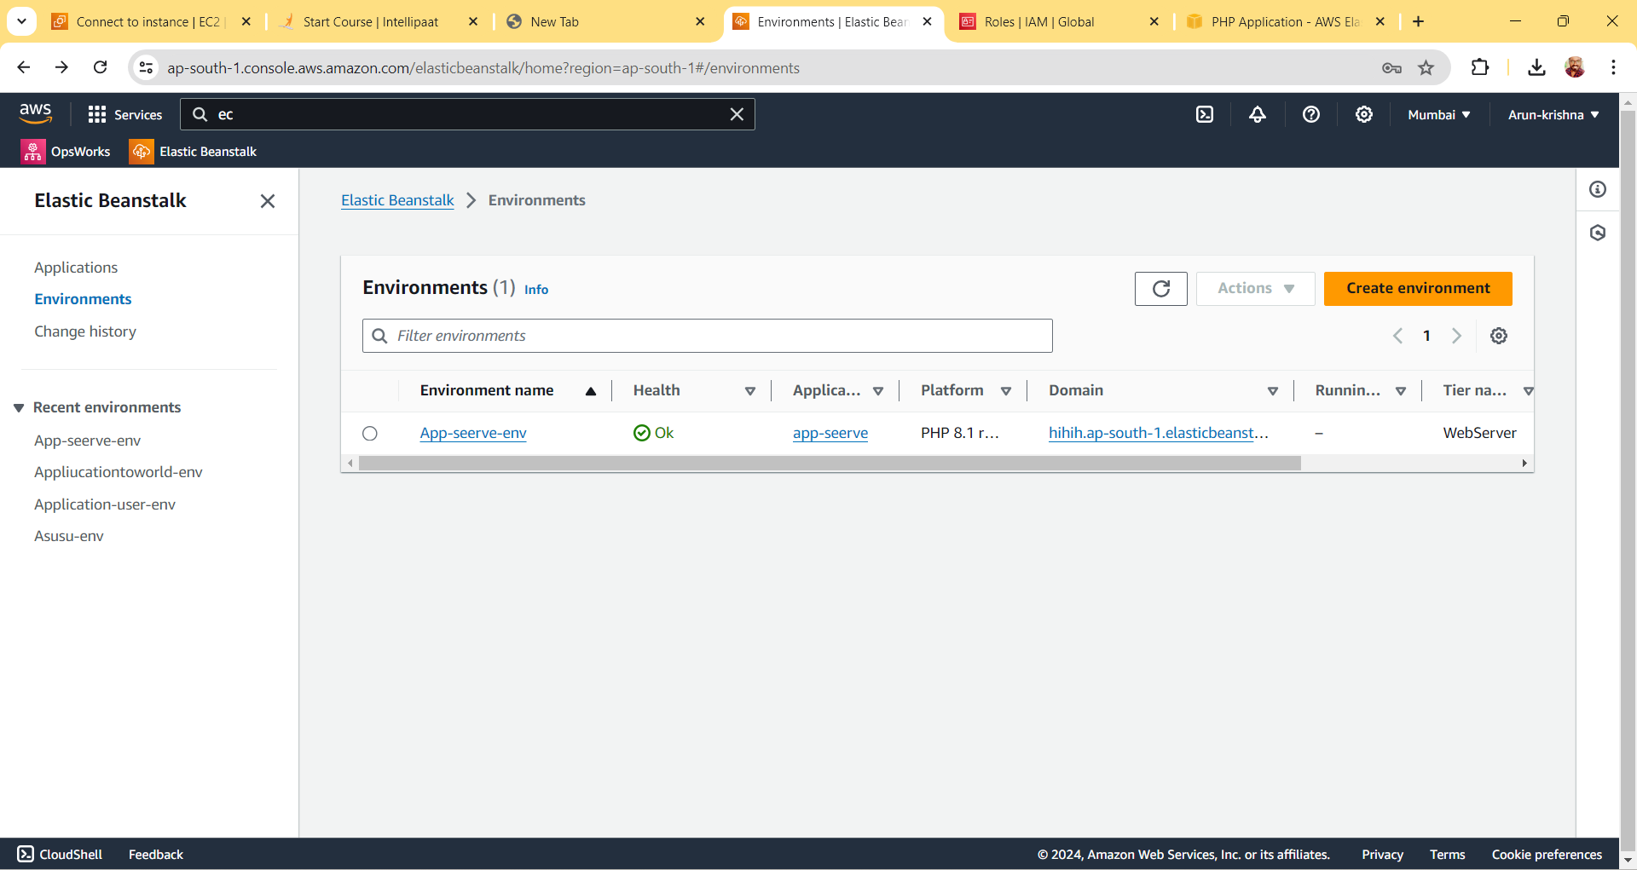  
  
  
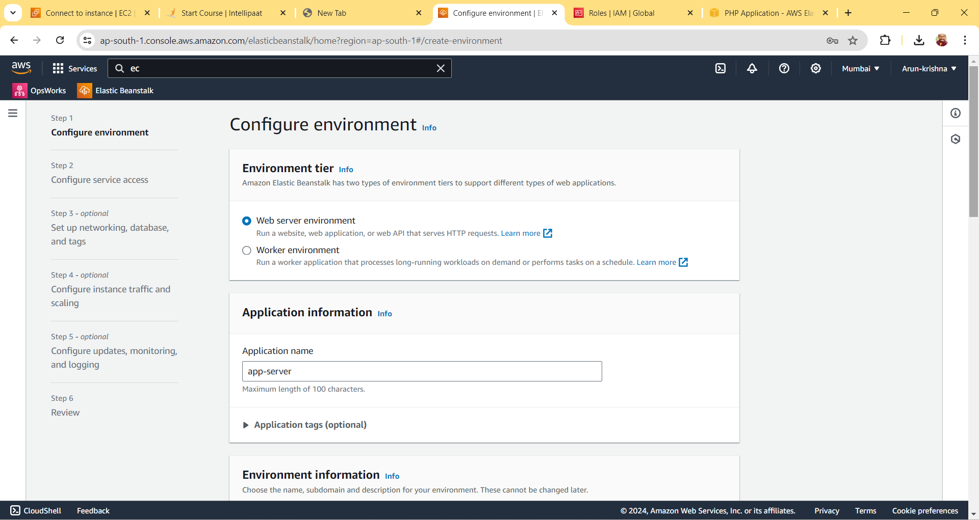  
  
  
  
  
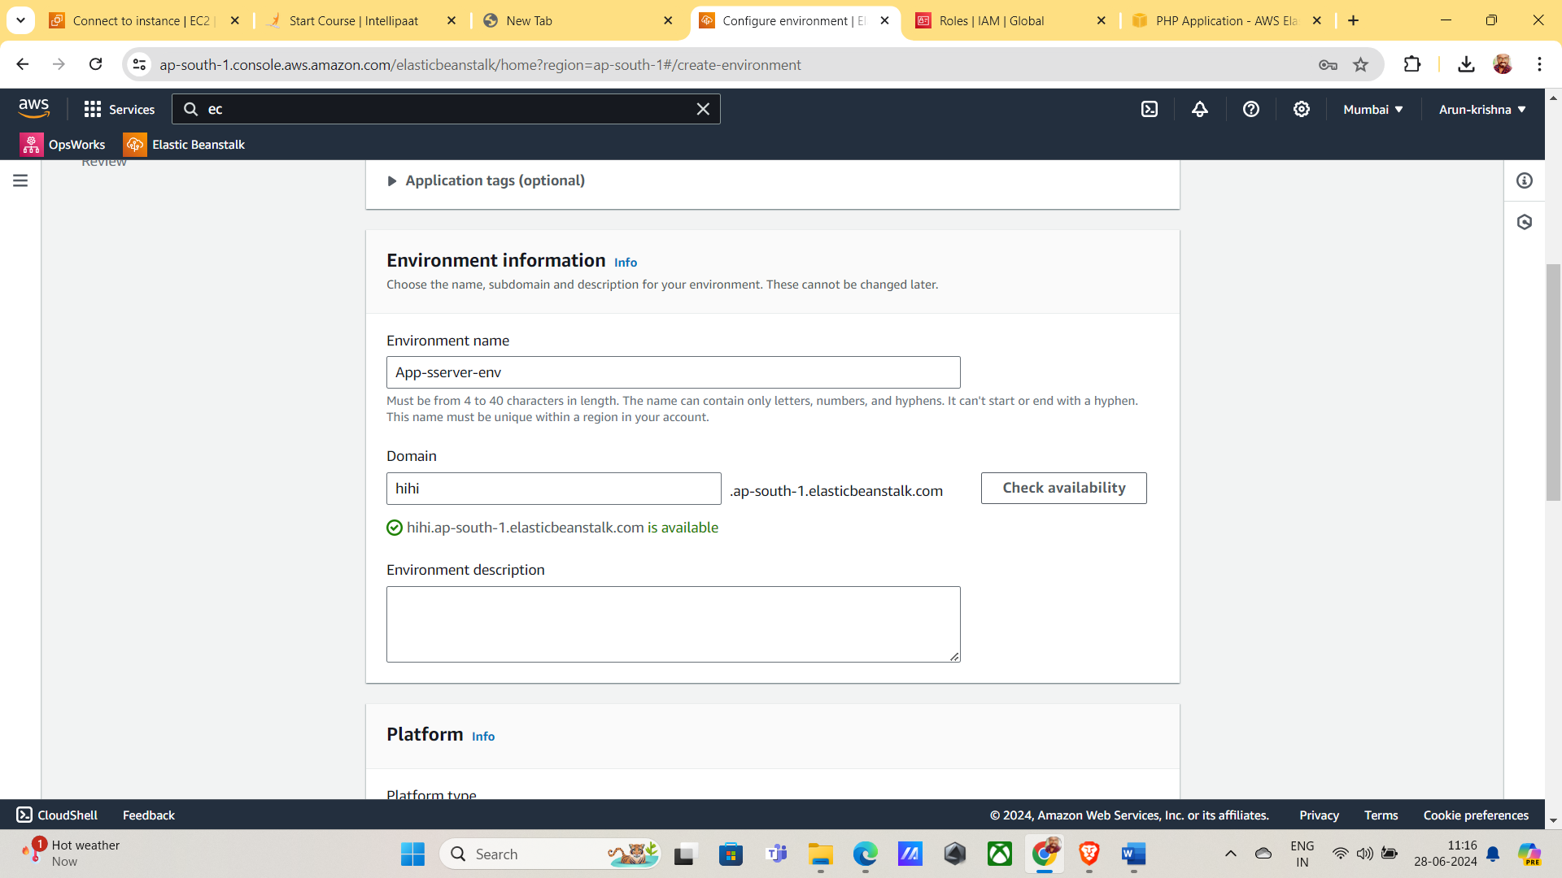  
  
  
  
  
  
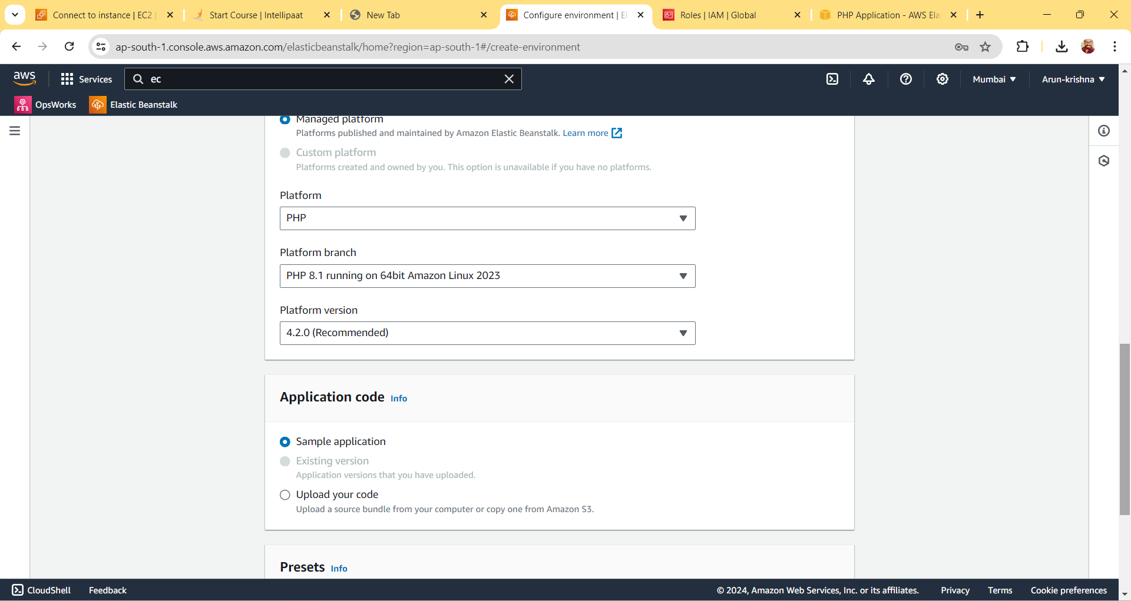  
  
  
  
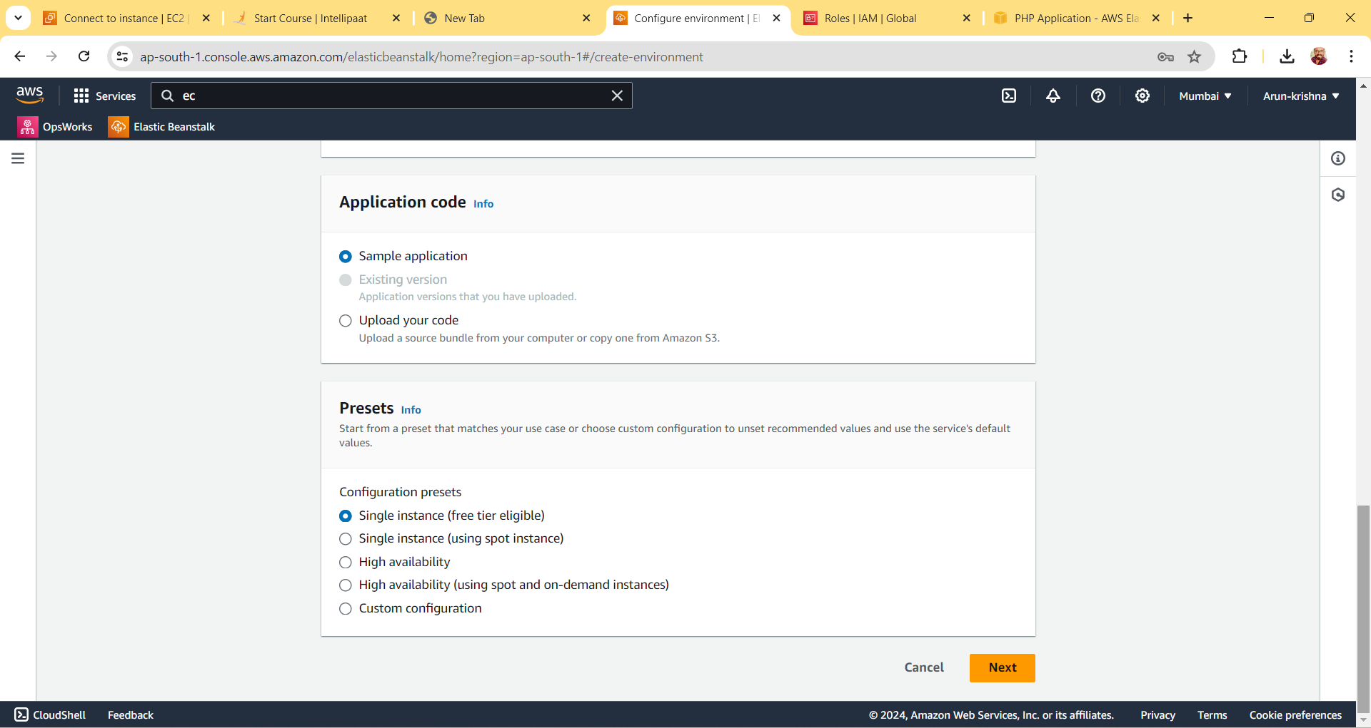  
  
  
  
  
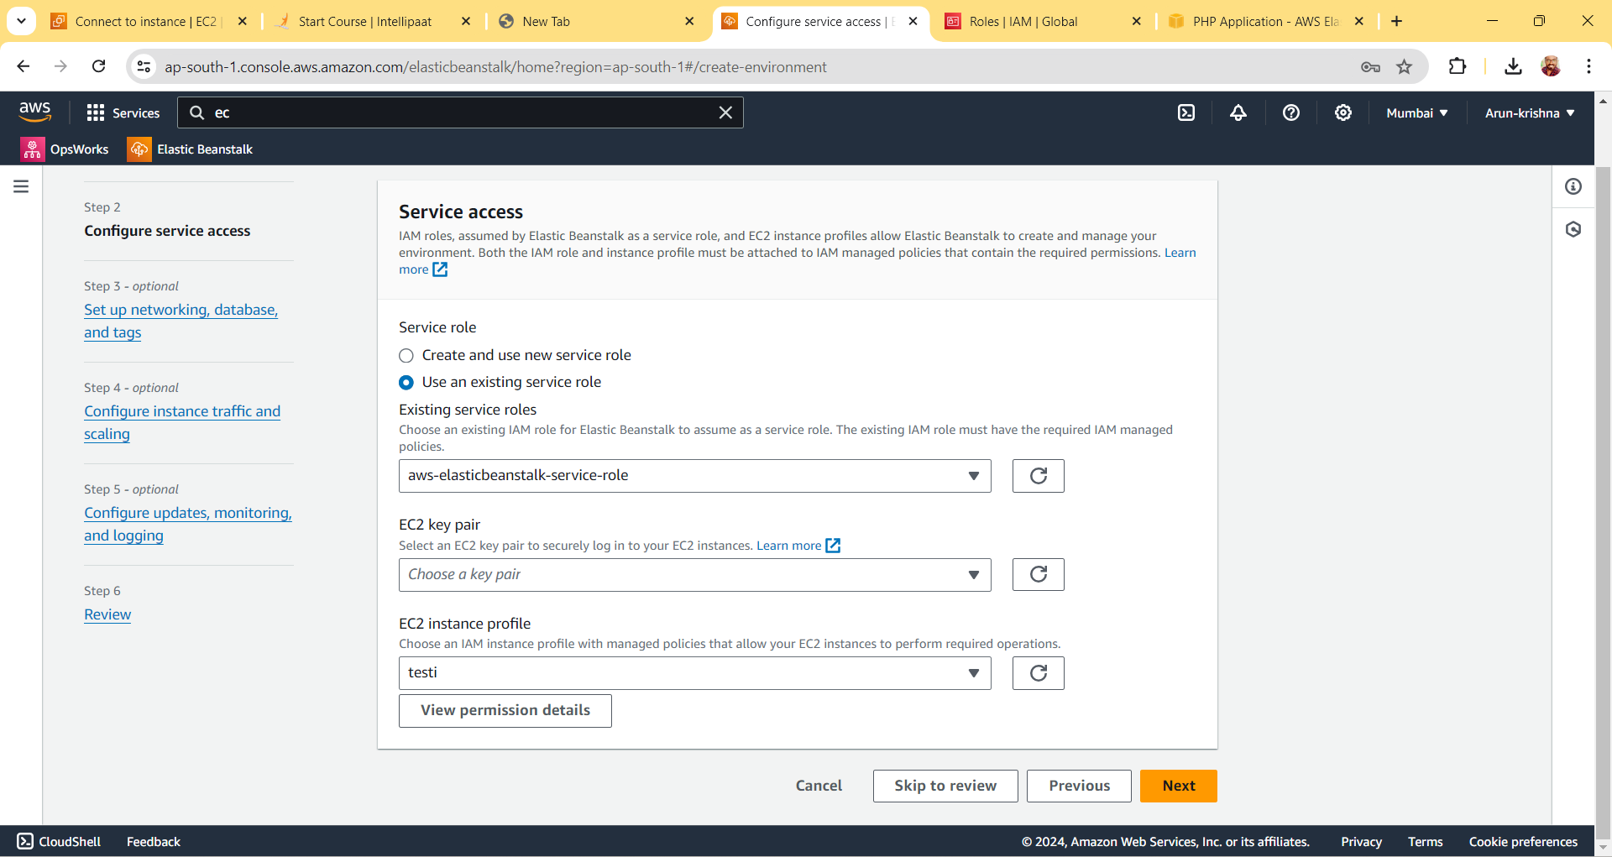  
  
  
  
  
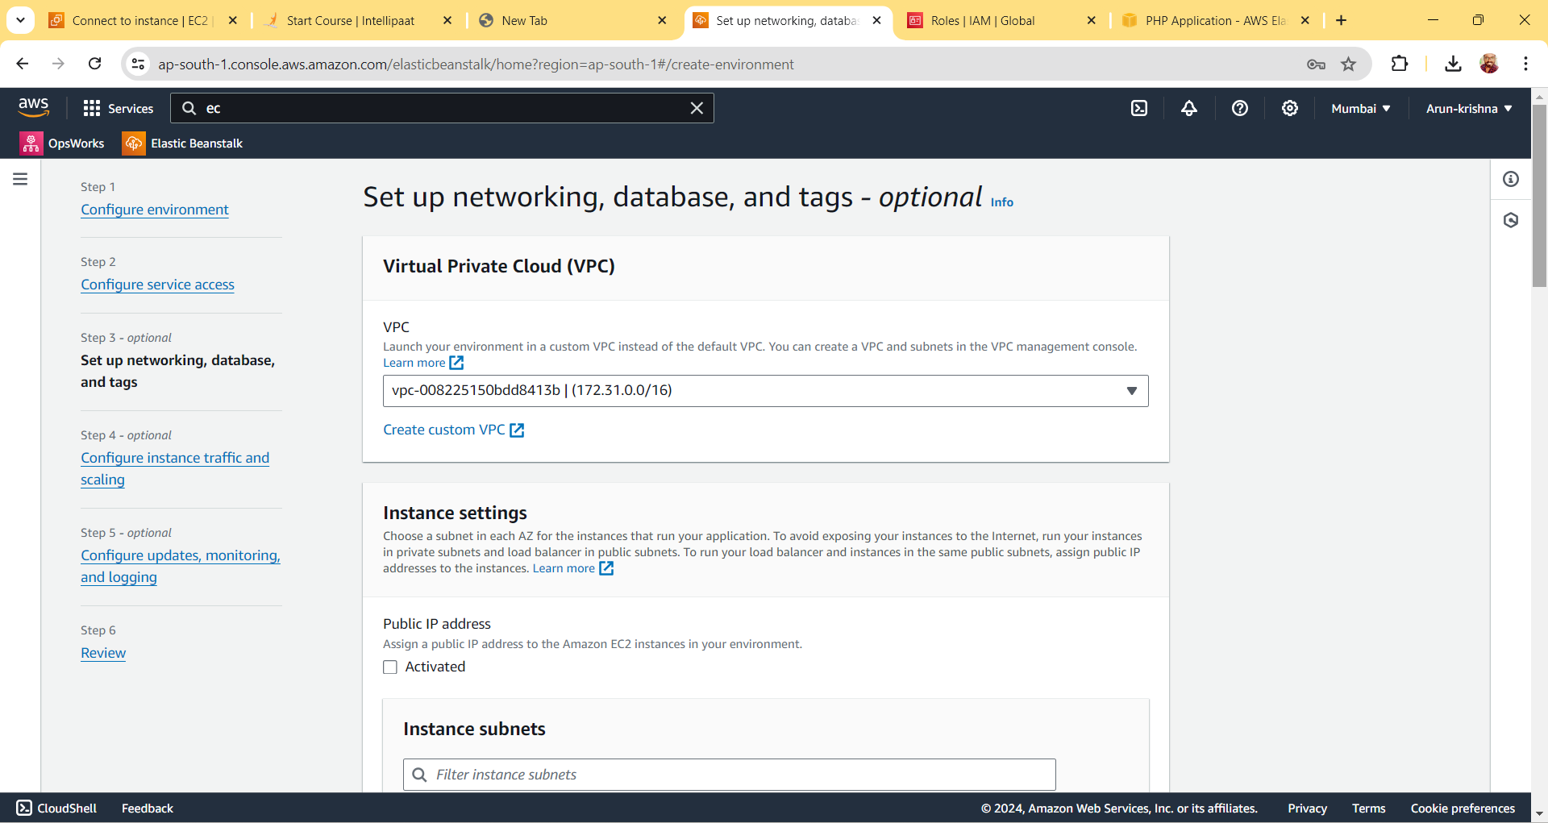  
  
  
  
  
  
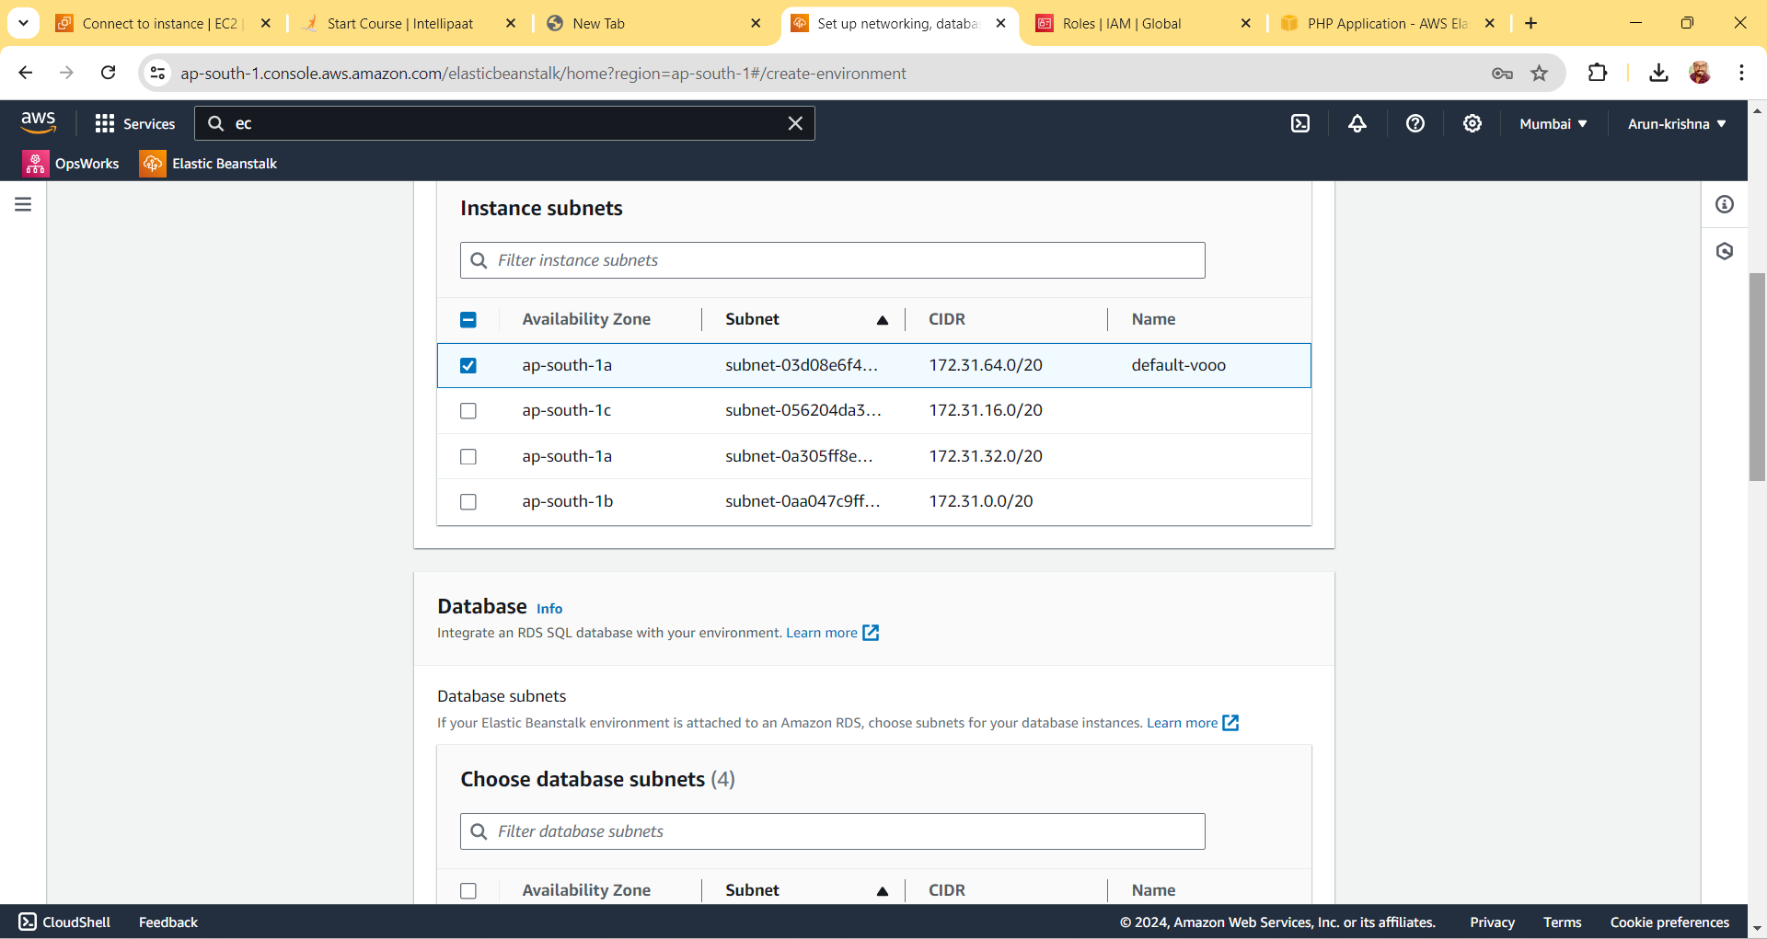  
  
  
  
  
  
  
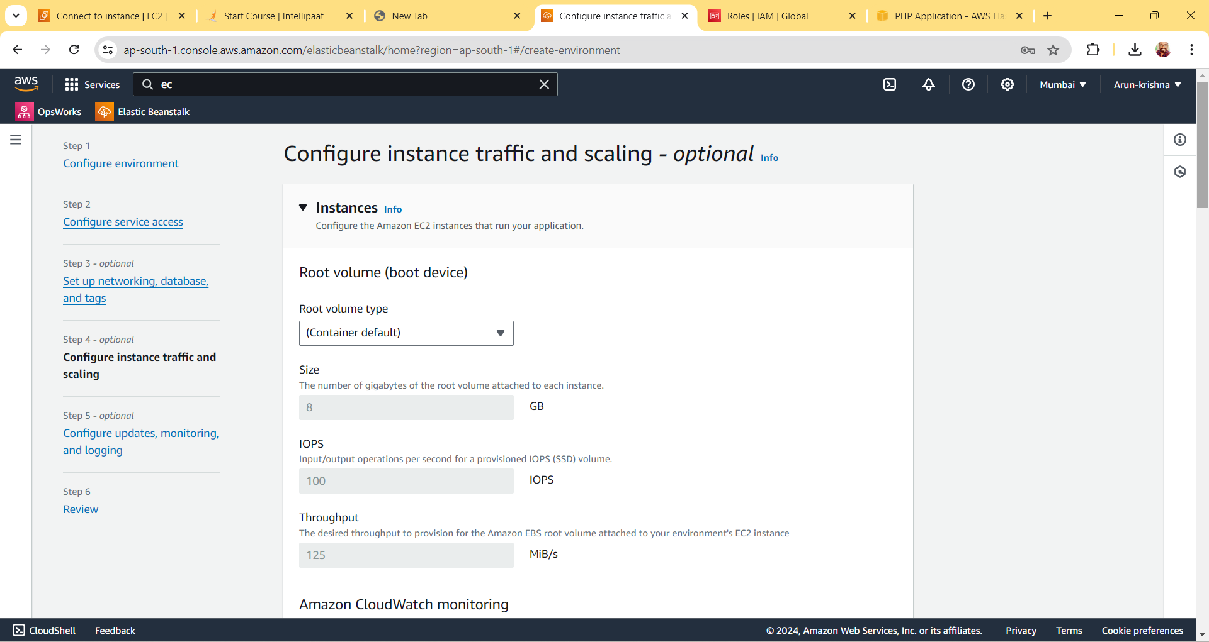  
  
  
  
  
  
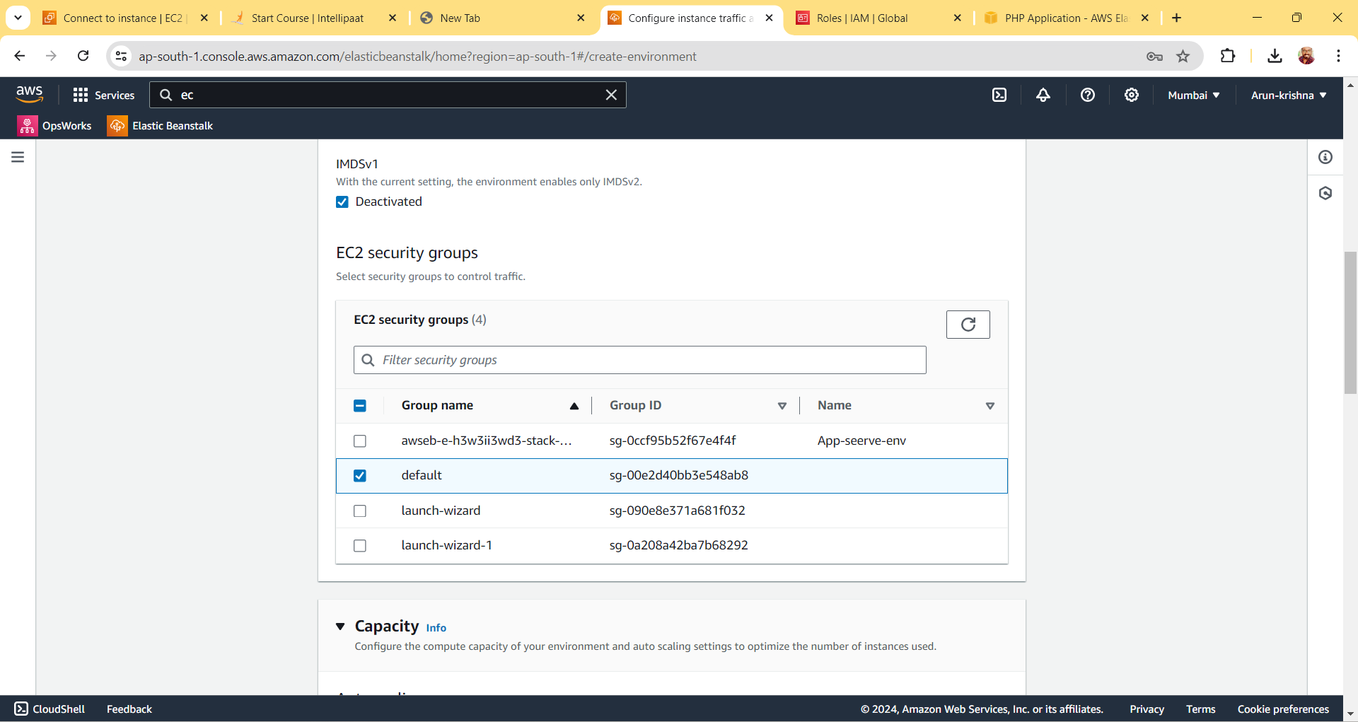  
  
  
  
  
  
  
  
  
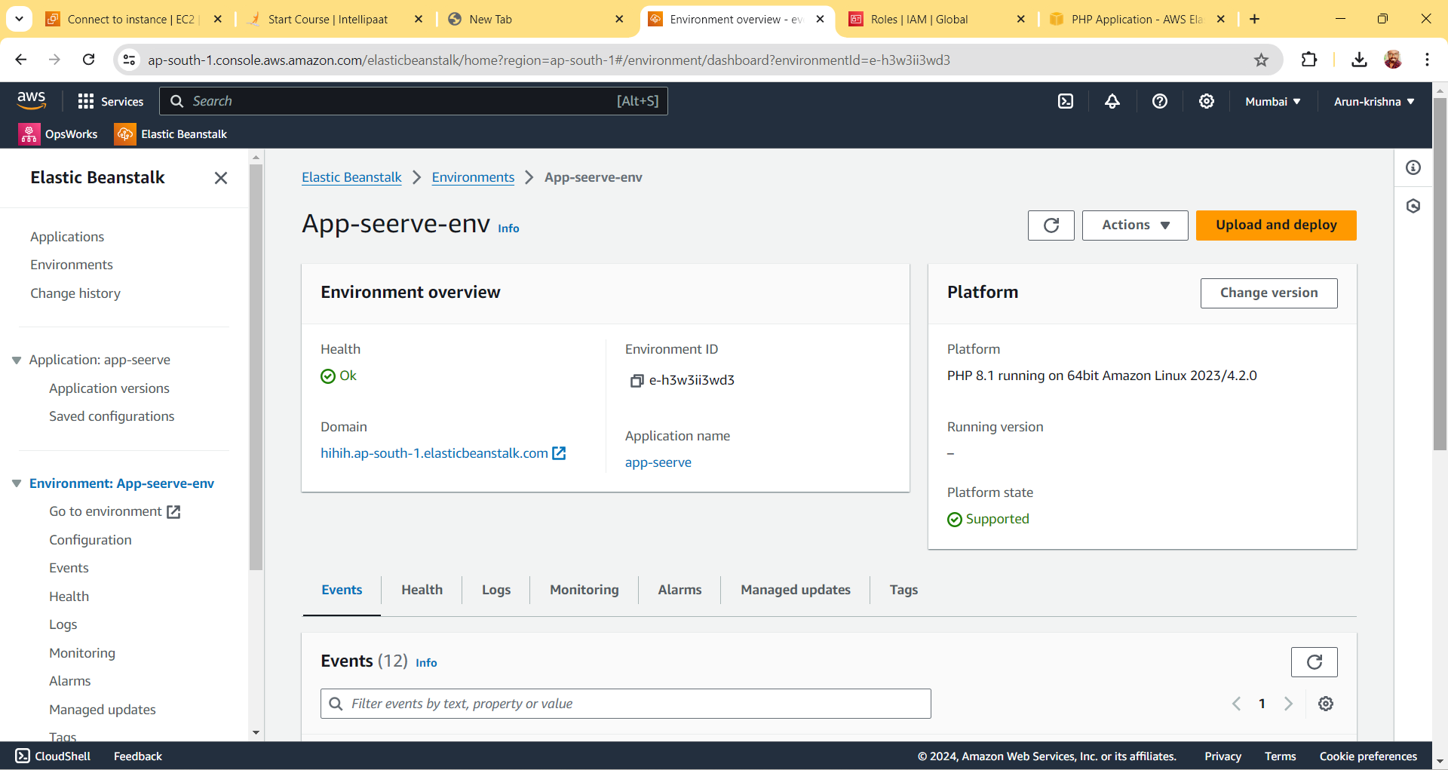   
  
  
  
  
  
  
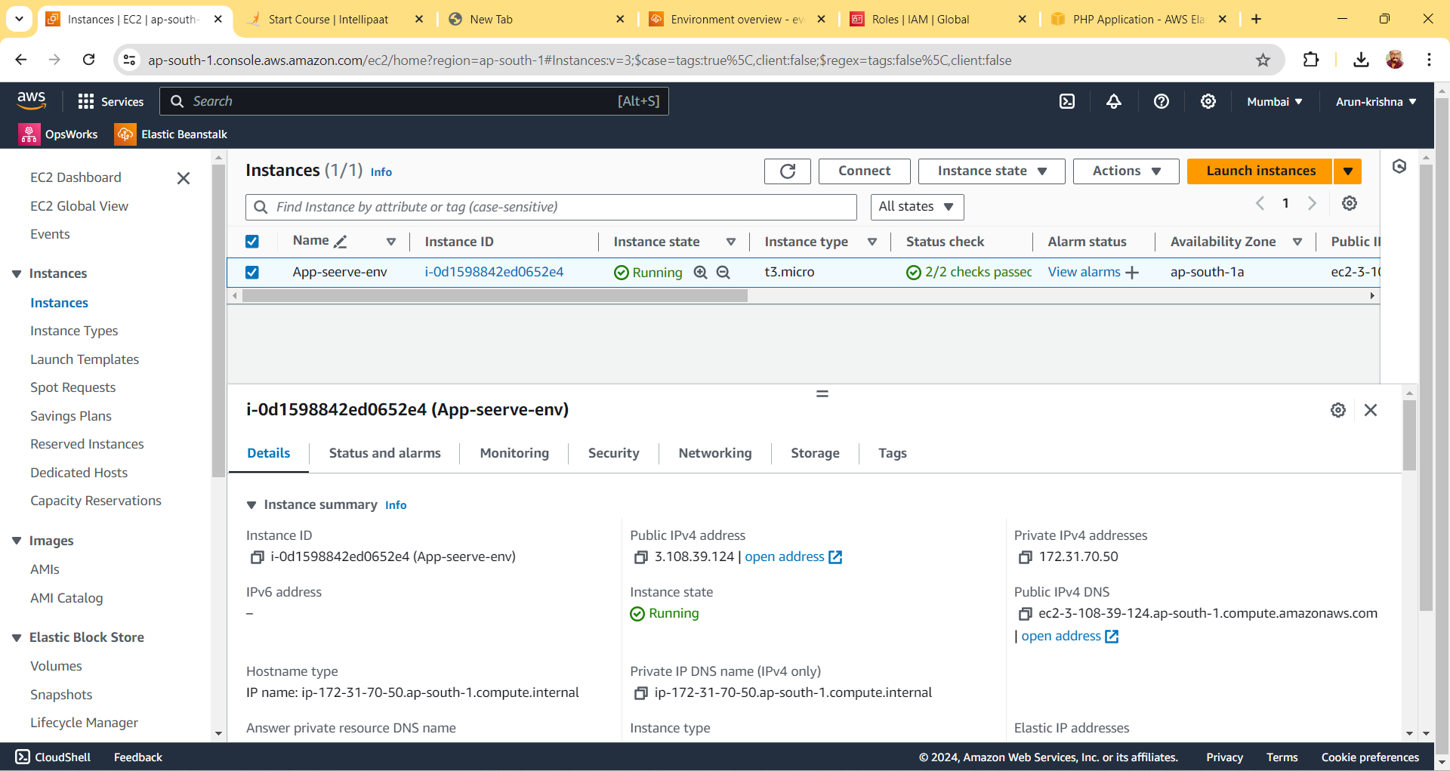

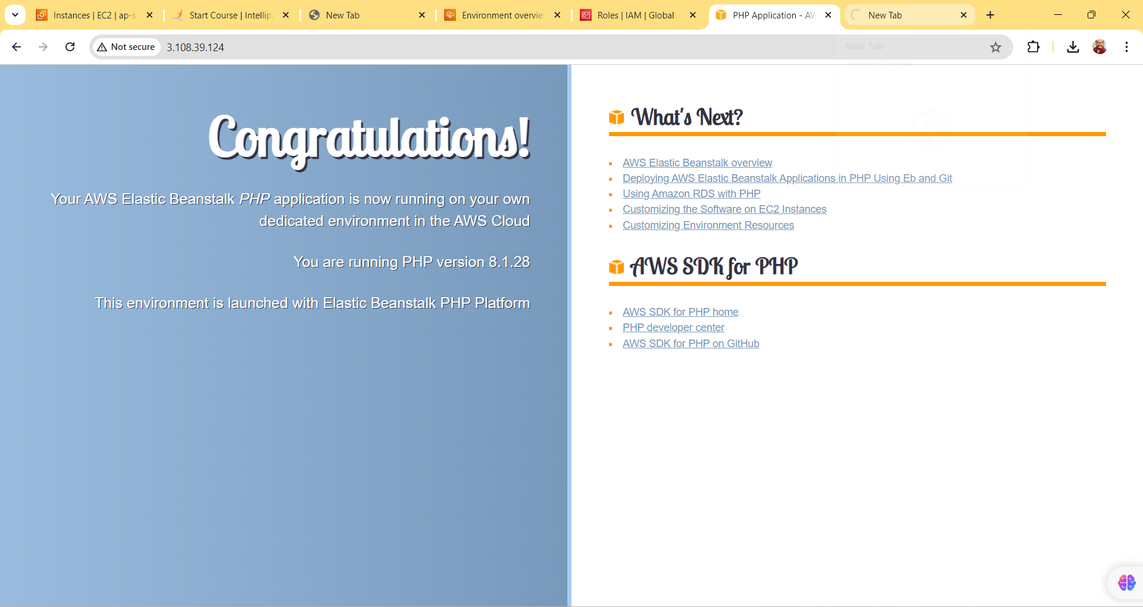

Upload a simple PHP file to the environment  
